Fourth Year Project
Summary of Work Done
Trevor Lewis

Proposed Project Aims

- To develop two or more prototype FPGA-based systems for encryption and compression of data
- To use at least two different design routes to achieve the first aim
- To benchmark each of the alternative systems produced
- To compare and contrast the results of the benchmarking of the prototypes with comparable software only solutions
- To use direct and indirect measures to ascertain the complexity of the two design routes under investigation
- To investigate Hardware-Software Partitioning tools
- To perform all these tasks to budget and to schedule

Guidelines for development of Project plan

The guidelines detailed in this section are based on an analysis of the project management of the HAWK system. Particular attention was paid to the Risk Management and the minutes of the HAWK project team. Additional guidelines are based on general guidelines for the development of successful software products.

Leave lots of time for research, specification and design

Most projects fail because the requirements were not correctly or fully captured and specified during the project initiation phase. Time expended re-working the design or revising the specification late in the development lifecycle often causes the project to run over budget or to be delivered late. A good design is usually a simple design, one that can be easily implemented. The extra time spent in design reduces the time needed for implementation. Good designs also result from good specifications; specifications that are verifiable, and have clear boundaries and criteria for success. Good specifications are the result of careful planning and consideration of the feasibility of what is being asked; both of which are related to the quality of the research undertaken at initiation. In order to do it right first time, one needs to leave ample time for research, specification and design.

Incorporate Risk Management in the project plan

This should ensure that risks to the success of the project are identified early and resolved. Alterations to the schedule may be necessary.

Testing, Testing and more Testing

When one reads the Appendix to the HAWK document, it becomes apparent that the main factor that prevented them from implementing more functions in FPGA, was time. The project team was not aware of some problems in the Handel-C environment, which make verification and validation difficult. For example, they observed that compilations often more than twenty minutes to complete. Hardware-Software Co-design is inherently concurrent and therefore difficult to test. It is therefore imperative that ample time be left for testing.

Important Milestones

The project plan should take into account the deadline for each project deliverable. In addition, the HAWK project team directors suggested that algorithms should be finished before Christmas and integration should start before Easter. It is a valid assumption to expect these two additional milestones should be applied to this project as the Project Directors for this project and the HAWK project are the same, as well as the fact that both systems utilise FPGA technology.

Hardware Platform Capabilities and Constraints

One of the major design-decisions taken early in the project was the choice of the re-configurable device. The re-configurable hardware development platform chosen was the RC1000 board from Celoxica™. Celoxica™ describes their board as a “high speed FPGA based parallel computing platform”. The RC1000 board is a “full length 32-bit PCI card”Error: Reference source not found with a programmable clock, Peripheral Component Interconnect (PCI) interface, 8MB of SRAM, which can support any XILINX® Virtex™ BG560 part with up to 2 million system gates. For this application we have chosen the XILINX® Virtex™ XCV1000, from the BG560 range, as the target FPGA. The XCV1000 has 1,124,022 system gates.

The RC1000 system clock can be programmed with frequencies ranging from 400KHz to 100MHz. The maximum frequency of this clock is only half that of the maximum of the XCV1000 so the performance of designs using the RC1000/ XCV1000 combination are limited by this factor.

Another performance limiting feature is the PCI interface. The XCV1000 supports both 33MHz and 66MHz PCI bus interface but the RC1000 only supports 32-bit, 33MHz PCI bus. This limits the PCI interface to 132Mbytes/sec bursts.

The 8MB of SRAM is for dynamic data storage and is accessible to both the onboard FPGA and the host CPU. This dynamic memory is organised as four 32-bit wide, 2MB banks (16-bit memory addresses for each bank). “Each of the 4 banks may be granted to either the host CPU or the FPGA in any combination”. For example, the FPGA may access three banks in parallel while the host CPU accesses the fourth.

Finally, “the board is equipped with two industry standard [PCI Mezzanine Card IEEE P1386.1] PMC connectors for directly connecting other processors and I/O devices to the FPGA… and host PCI bus…. A 50-pin unassigned header is provided for either interboard communication, allowing multiple RC1000s to be connected in parallel or for connecting custom interfaces.”Error: Reference source not found

The development tools for the RC1000 include Celoxica™ DK1 Design Suite (with Microsoft C++V4.0 or later compiler) and the XILINX® Alliance Series and Foundation Series software tools and other EDA tools. The software runs on most flavours of Microsoft Windows as we as Intel-based Linux Systems.
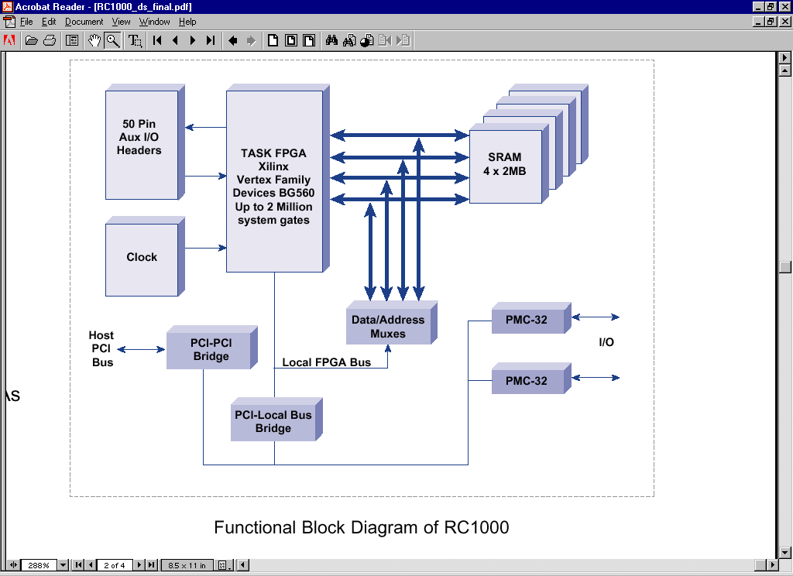
Figure 1 : Functional Block Diagram of RC1000Error: Reference source not found

References

Reconfigurable Hardware Development Platform – RC1000, Version 1.0, Winter 2001, http://www.celoxica.com
http://www.alphadata.co.uk/dsheet/adc-rc1000.html

